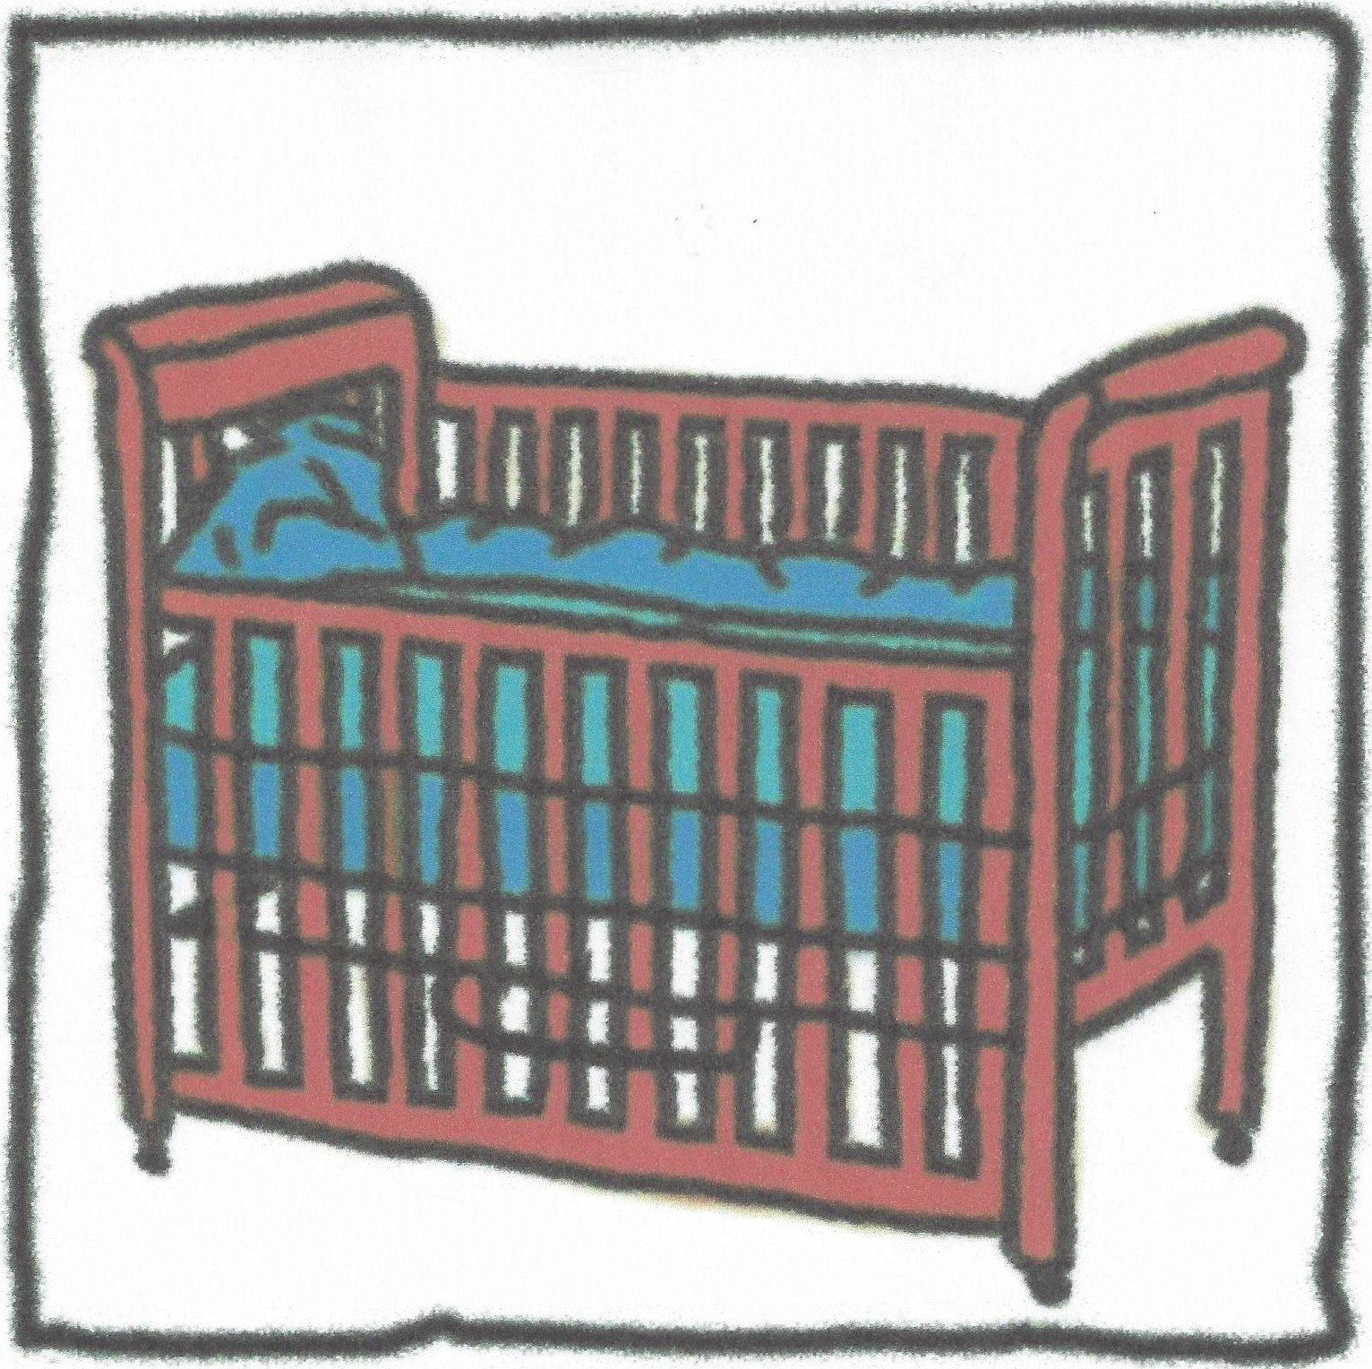What Is SIDS?
(SuddenInfant Death .
Syndrome)

Page l

Sudden Infant Death Syndrome

What i s SIDS?
Sudden Infant Death Syndrome (SIDS) is the diagnosis given for the sudden death of an infant, 1month to 1year of age, which remains unexplained after a complete investigation. The investigation includes an autopsy, examination ofthe death scene, a review of the child's symptoms or illness the infant had prior to the death, and any other pertinent medical history. Because most cases of SIDS occur when the baby is sleeping in a crib, SIDS may also be known as crib death. The event may occur wherever the infant is sleeping, not necessarily the crib.

SIDS can occur anytime between 1month and 1year of age, however, 90% of the deaths occur before the age of 6 months, with the highest concentration between 2 and 4 months. Approximately 3,000 babies die of SIDS in the U.S. each year, and 218 babies died in Texas of SIDS during 1999. There is an increase incidence in the winter months. It is more common with male children than female, (60% vs. 40%). SIDS happens suddenly and silently in a seemingly healthy infant. The death leaves many unanswered questions, causing intense grief for parents andfamilies.

SIDS i s not:
SIDS is not hereditary, contagious, caused by immunizations, choking, suffocation, or apnea. It is not child abuse, and not the reason for all unexpected infant deaths.

Which babies are at higher risk?
Infants born weighing less than 5 to 6 lbs.,premature babies, twins or triplets, babies born to mothers younger than 20 years old, and babies born to mothers who smoked, or used drugs or alcohol during the pregnancy are at a higher risk of SIDS. Mothers who smoked during pregnancy increase the risk by three times. Factors after birth that increase the risk of Sudden Infant Death Syndrome are babies that sleep on their stomachs and smoking in the infant's environment. Smoke in the environment doubles the risk.

What can be done to reduce the risk of SIDS?
Even though SIDS cannot be completely prevented, there are things that can be done to reduce the risk of SIDS.
- Place babies on their back for sleep. Always position the baby on their back for nighttime and naptime. Do not place the baby on their stomach or side. Starting in 1992, the American Academy of Pediatrics (AAP) recommended that babies be put down to sleep on their backs instead of their stomachs and, in 1994,began the nationwide "Back to Sleep" campaign. Since this recommendation, the incidents of SIDS have reduced 40%, which means saving about 2000 babies each year from SIDS. The concern expressed with placing babies on their backs is that those infants may choke. There is no evidence to support this as researched by countries where "back to sleep" was the standard, and these countries also had a much lower incident rate of SIDS.
- Place the baby on a tight-fitting mattress in a crib meeting current safety standards. Don't put babies to sleep on soft mattresses, sofas, waterbeds, pillows, beanbags or other soft surfaces.

L

- Remove all the fluffy and loose bedding from the sleep area. Pillows, quilts, comforters and stuffed toys should not be in the sleep area. If using a blanket, it should be thin. Place the baby in the crib with his feet at the foot, and tuck the blanket around the crib mattress, only as far as the baby's chest. Blankets and coverings can bunch up around the baby's face, which can cause potentially dangerous re-breathing of stale air. Also, make sure the baby's head is uncovered during sleep.
- Make sure the baby does not become over heated by wearing too much clothing, heavy bedding or too warm a room. Babies cannot regulate their own body temperature well, so the baby should be dressed in whatever clothing is comfortable to you as an adult. Remove outer wear (jackets, sweaters, hats) once inside so not to overheat the baby.
- Keep the environment smoke-free.
- Breast-feed the baby, if possible. Breast-fed baby's are at lower risk for respiratory illnesses. The increase of SIDS during the winter months may be due to use of heavier bedding, over dressing the baby, and increased respiratory infections which may be triggering events for a SIDS death.

What causes SIDS?
While the causes of SIDS are still unknown, a triple-risk model is now often used to describe the elements that occur together that may lead to the sudden death of an infant.

- During the first 6 months of life, the rapid growth that occurs with infants may periodically destabilize their system that controls sleeping and waking, breathing, heart rate, blood pressure and temperature - this is known as the critical development period.
- The vulnerable infant has an underlying defect in the brain that controls breathing and heart rate during early life, and
- There are outside or environmental challenges present that a normal baby can overcome, but an already vulnerable infant might not. Stressors such as second-hand exposure to tobacco smoke, stomach sleep position or an upper respiratory infection alone do not cause death in an infant, but may further tip the balance against an infant's chances for survival. According to this model,all 3 elements must come together for SIDS to result. The babies seem to not have enough protective responders to handle changes in oxygen and carbon dioxide levels.

Child Care providers need to consider:

Study results released in September 2000, evaluating the circumstances of nearly 2000 SIDS deaths, found that 20% of those SIDS deaths occurred in child-care settings. Thought to be a contributing factor was a high percentage of the caregivers were not aware of the "back to sleep" recommendation and other risk reducing techniques - probably because most of them had children that were older than when the recommendations came out in the 90's.

Also, it has been found that babies who routinely are used to sleeping on their backs and are then placed on their stomachs for sleep, have a 20 times greater risk of SIDS. A well-

intentioned, yet possibly uninformed caregiver, feels the baby would "sleep more soundly" on their stomach. It is essential that sleep position be consistent for nighttime, and naptime, and from parent to grandparent to child-care provider.

"Tummy time" while the baby is awake and being observed, is important to develop shoulder and neck muscles and coordination, as well as reduce the flattening that can develop on the back of the head.

If you have a child in care with reflux, respiratory disease or some other breathing dysfunction, be sure and obtain information from the child's physician on the recommended sleep position.

Shaken Baby Syndrome

What is Shaken Baby Syndrome?
Shaken Baby Syndrome (SSS) is the medical term used to describe the violent shaking and resulting injuries sustained. It is one of the leading forms of fatal child abuse. When a baby is vigorously shaken, the head is moved (or snapped) back and forth. This whiplash motion can cause delicate veins inside the head to rupture and bleed. The brain actually bounces inside the skull cavity, which bruises the brain tissue. Once the bleeding begins to pool,it causes swelling and pressure. Bleeding occurs behind the eyes, (retinal bleeding) which can cause blindness. When the blood vessels to the brain are torn away, brain damage results. Once the brain cells are damaged, they are never regenerated or replaced and cannot be repaired. In addition, the swelling and pressure causes the brain to push and squeeze down on the brainstem, which controls vital functions such as breathing and heartbeat. lfthe swelling and pressure are not controlled, (usually through medications and/or surgery) vital functions may stop and the child could die.

Almost 25% (one out of four) of babies with SSS die. The death usually occurs within hours or days. It occurs most often in infants under 6 months old, but can occur in children up to age 3. Severe signs and symptoms of SSS include breathing problems, seizures and unconsciousness. More moderate symptoms that indicate severe shaking has occurred are inability to suck, eyes glassy or unfocused, grimacing or twitching and lethargy. The milder symptoms are poor feeding,vomiting,irritability or poor sleeping.

The survivors often suffer from varying degrees of cerebral palsy, paralysis, seizures, blindness, hearing loss, or developmental delays. It could also cause speech difficulties, behavioral problems or a vegetative state. About 15% of the victims may have no permanent damage.

How does it occur?
A baby's head and neck are susceptible to head trauma because their heads are large and heavy (making up to 25% of their total body weight) and their neck muscles are not developed enough to support the force of shaking. The brain tissue is also very fragile. When a child is shaken in anger or frustration, the force is multiplied five or ten times more than if the child had simply fallen or tripped.

Most of the time, Shaken Baby Syndrome occurs when an angry or frustrated adult shakes a child that will not stop crying. Inconsolable crying,whether from colic, illness, pain or just plain fussiness is the number one reason that sparks shaking. Infants cry most between the ages of 6 weeks and 4 months. Other incidents that provoke SSS include trouble with toilet training or misbehavior, such an interrupting. The shaking may be intended to emphasize the disciplinary measure. It is estimated that 25% - 50% of parents and caretakers are not aware of the effects that shaking a baby can cause. Many experts believe that, in most cases, no serious harm was intended - they just wanted to stop the crying or the undesirable behavior. They loose control and don't stop and think first.

The majority of the perpetrators of SSS are male (70% or higher) and most of the time it is

the baby's father, yet the mother's boyfriend, male child-care providers or stepfathers are also responsible. Female child-care providers make up about 17% while the mothers are responsible in about 13% of the cases. The victims of Shaken Baby Syndrome are boys 60% of the time.

What can be done to prevent Shaken Baby Syndrome?
Taking care of a child can be very difficult work. The most effective way to prevent SSS is to educate parents, child-care providers, babysitters, family members and siblings of the dangers of shaking a baby. Also being aware of appropriate ways to help a baby stop crying is helpful. Infants use crying to communicate needs or sometimes relieve stress.

Suggestions for Caregivers

- Check the baby's diaper and change it, if needed
- Hold the baby against your chest and walk with him
- Make sure the baby is fed, and burped
- Lay the baby down across your lap and rub or pat his back
- Make sure the clothing is not too tight
- Hug and cuddle the baby gently
- Sing or talk to the baby
- Put the baby in a swing
- Play soft music
- Offer the baby a pacifier
- Rock the baby gently, either in a rocker or by swaying back and forth
- Take the baby outside for fresh air
- Gently rub the baby's head
- Reassure with soft words
- Offer a noisy toy or rattle
- Do slight knee bends while holding the baby
- Message the baby's body or limbs gently
- Gently touch the soft surfaces of the baby'sface
- Take the baby for a stroller ride
- Swaddle the baby in a blanket

Babies are fragile. Please don't shake a child.
NEVER, NEVER SHAKE A BABY!

The more relaxed you remain, the easier it will be to console the child. Babies are sensitive to the tension around them. Letting your frustrations turn to panic or anger can intensify the infant's crying. When you are feeling stressed, do not pick up the baby until you feel calm. You could sit down, close your eyes and count to 20. Try taking slow, deep breaths. You may be better off asking for another caregiver to take over for a while.

"An ounce of prevention is worth a pound of cure"
Funding for prevention programs continues to be limited although the benefits of prevention can far outweigh the costs for a surviving Shaken Baby Syndrome child over their lifetime. It is estimated that just the initial hospitalization for a SBS child is $75, 000 - $95,000. This does not include continuing rehabilitation or medical expenses incurred after the child goes home. Most of these costs are absorbed by society through insurance, government assistance, and increased special education costs.

The 1999 Texas Legislative session (Human Resources Code Section 42.0421.b) mandated a new training requirement for caregivers who provide care for children under 24 months old in day care centers, group day care homes and registered family homes. The child-care providers are required to receive annual training regarding

  - recognizing and preventing shaken baby syndrome
  - preventing sudden infant death syndrome, and
  - understanding early childhood brain development. Also, before a new employee works with this age group, they must have completed the training.

If you become aware of a situation where a child has been shaken, make sure the child gets immediate medical attention. The bleeding inside the brain needs to be treated as soon as possible.

A complimentary Shaken Baby Syndrome kit with fact sheets and poster can be obtained from the Foundation for the Prevention of Child Abuse/National Exchange Club by calling 1.800.924.2643.

Internet websites with additional information include
www.shakenbaby. com
www .preventchildabuse.com www .sbsplus.com

Early Childhood Brain Development

Why should caregivers know about brain development?

The brain is the part of the body that allows us to feel joy or despair, to respond to others in a loving or angry way, to use reason, or to simply react. These capacities don't just magically appear, they result from the interplay between a child's heredity and the experiences they have duringchildhood.

At birth, the brain is unfinished. The parts of the brain that handle thinking and remembering, as well as emotional and social behavior, are underdeveloped. The fact that the brain matures in the world, rather than in the womb, means young children are deeply affected by their early experiences. Their relationships with parents and other important caregivers don't just influence their moods, but actually affect the way children's brains become "wired." Researchers now confirm that the way infants are interacted with and the experiences provided for them have a major impact on the child's emotional development, learning skills and how they function later in life.

How does the brain form "connections"?
At birth, the brain contains about 100 billion brain cells that are yet to be connected into functioning networks. By the time a child is three, the brain has formed about one thousand trillion connections between these brain cells. Some of these connections become permanent, while others disappear as the child grows. How does the brain know which connections to keep? Connections that are used repeatedly during the child's early years become the foundation for the brain's organization and function throughout life. In contrast, a connection that is not used results in a lack of development or even the disappearance of these connections. For example, a child who is rarely spoken to or read to in the early years may have difficulty mastering language skills later on. By the same token, a child who is rarely played with may have difficulty with social adjustment as he or she grows.

Brain cells are designed for making connections. Each cell sends signals out to other brain cells and receives input from other cells. The signals, in the form of electrical impulses, travel down the length of the nerve cell. With the help of chemicals (such as serotonin) they travel from cell to cell,creating connections. Repeated activation of networks of neurons strengthens these connections.

What should be done to encourage appropriate brain development?
When a caregiver rocks, touches, talks to, sings to and smiles at an infant, this promotes brain development. Babies experience relationships through their senses - vision, hearing,touch, smell and taste. They read the way you look into their eyes, they see the expressions on your face, they hear you cooing,singing,talking and reading, and they feel you holding or rocking · them. Touch is especially important, as holding and stroking stimulates the brain to release important hormones necessary for growth.

Be warm, loving, and responsive.
Children who receive warm and responsive caregiving and are securely attached to their caregivers cope with difficult times more easily when they are older. They are more curi­ ous, get along better with other children, and perform better in school than children who are less securely attached.

Infants communicate their needs, preferences, and moods to the adults who care for them by the sounds they make, they way they move, their facial expressions and the way they make (or avoid) eye contact. Children become securely attached when caregivers try to read these signals and respond with sensitivity. They begin to trust that when they smile, someone will smile back, that when they are upset, someone will comfort them, and that when they are hungry, someone will feed them.

You might think that a newborn might get spoiled with all this attention, but studies show that newborns who are more quickly and warmly responded to when crying typically learn to cry much less and sleep more at night. A baby expresses his distress by crying. When the caregiver responds with food, warmth, or comfort, the baby tends to be calmed. The stress-response systems in the brain are turned off and the infant's brain begins to create networks of brain cells that help the baby soothe himself.

Talk, read and sing to the child.
Infants learn from "conversations" even when they cannot understand what you are saying. When babies hear the same words over and over, the parts of the brain that handle speech and language develop. The time used to change a diaper or feed an infant can be an oppor­ tunity to spend some individual time with that child, talking,singing and expanding on their own coos and gurgles.

Read picture books and stories to infants. By 6 months, infants show excitement by widen­ ing their eyes and moving their arms and legs when looking at a book with pictures of babies or other familiar objects.

Establish routines.
Daily routines associated with pleasurable feelings are reassuring for children. "Repeated positive experiences provide for a sense of security. It helps a child learn what to expect from his environment and how to understand the world around him.

Encourage safe exploration and play.
Play is an important learning experience. Look around the environment you are providing for infants.· Make sure there are enough interesting things for them to look at - not too many, but that there are things for the infant to focus on one at a time. Put the infants on the floor in safe areas that encourage them to move about. Keep things in containers that the infant can dump and fill. Adults should encourage exploration, and then also be recep­ tive when the child needs to return to them for security.

,

HELPFUL
- The attention and support of a kind and interested adult
- Child care that is continuous and predictable
- A caregiver whom the child likes and trusts
- A safe and clean place to play
- Physical activity, interesting toys and fresh air
- Nutritious meals and snacks

HARMFUL
- Hearing harsh voices or "no" all day, not being picked up when crying or listened to when upset
- Frequent caregiver turnover and a non­ predictable schedule
- A caregiver who is too tired or overwhelmed by caregivingresponsibilities or does not want to care for children
- Lack of toys, over-use of television

By providing consistent and responsive caregiving,you can ensure that a child will have the best opportunity for healthy emotional and social development. Every important caregiver has the potential to help shape a young child's future.

www .zerotothree.org www.iamyourchild.org

