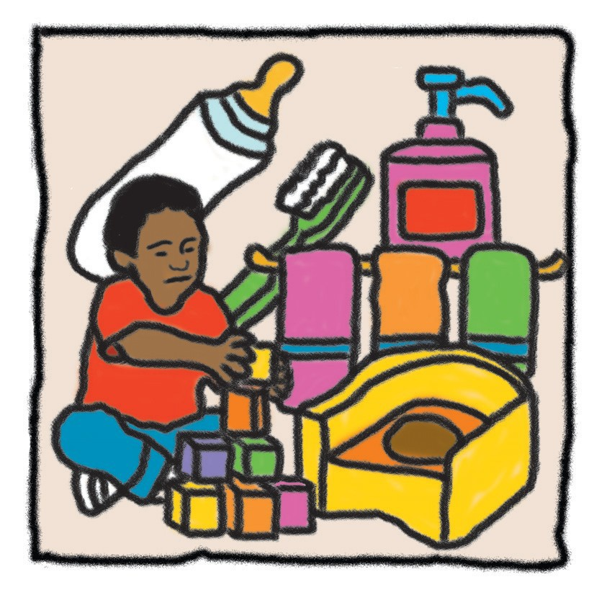

Health Precautions
Training Review Module 3 ClockHours

Instructions For Completing This Training Module
Table of Contents

Unit 1 -­‐‑ Daily Health Routines

- After reviewing this material with your day home rep-­‐‑ resentative, please read and study the material carefully.
- Complete the test for the material and return it to Child Food Program Of Texasatyourconvenience. There is no deadline to have this test back to us.
- When we receive your completed test, we will evalu-­‐‑ ate it and then send you a certificate for 3 clock hours for completing this material.

Objectives
- To plan and conduct daily trainings which will help in preventing illnesses.
- To conductdaily health checksto identify existing problemsforwhichmedicalhelpmaybeneeded.
- To screen on a periodic basis to identify those children in need of referral to other professionals
Toileting Pg 3
Toilet Training Pg 3
Facilities for Children Pg 4
Bathroom Guidelines Pg 4
Cleanliness Pg 4
Eating Pg 5
Washing Hands Pg 5
Basic Foods Pg 5
Food Servings Pg 5
Bottle Feeding Pg 6
Dental Care Pg 6
Careof Teeth Pg 6
Brushing the Teeth Pg 7
Maintaining Sanitary Conditions Pg 7

Unit 2. -­‐‑ Daily Health Check
Observations Pg 8
Recording Observations Pg 9

Unit 3. -­‐‑ Periodic Screening and Reporting
Health Pg 10
Vision Pg 13
Hearing Pg 14
Speech Pg 16
Motor Skills Pg 18
Behavior Pg 20
Learning Pg 22

Daily Health Routines

It is much easier to care for children when they can take care of their own toileting, eating, and dental needs.
Teaching each child the right way and stressing cleanli-­‐‑ ness takes time and effort on your part, but it is worth it in the long run.
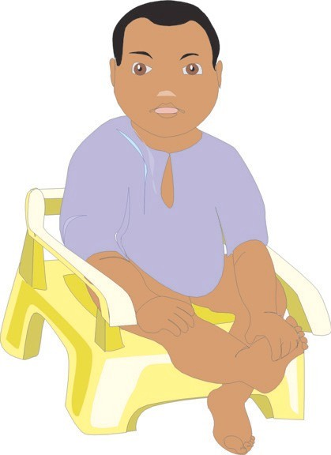The major reason for teaching proper selfcare is that ill-­‐‑ nesses are often carried through lack of cleanliness. Chil-­‐‑ dren can learn to brush their teeth, wipe themselves, and wash their hands independently at a young age. In fact, childrenenjoytheritualandroutineofwashingwhen they are notrushed.

Toileting
Toiletingandwashingroutinesareanimpor-­‐‑ tantpartofthechild’sneeds. In additionto teaching good health habits, these routines provide a way of learning independence, responsibility, cleanliness, and how to followdirections. Whenseveralchil-­‐‑ dren are together, as in a day-­‐‑care center or day home, they also
learn courtesy, sharing, and how to help others.
It is most important that these routines be pleasant, leisurely experiences and viewed as fun ratherthanchores. Never shame, rush, orprodchildrenwho are learning to take care of their own needs.

Toilet Training
Before you can start any kind of toilet train-­‐‑ ing, children should be able to walk and say a few words. Usually children cannot control their muscles enough for training until they are 18 months old, and many children are 22-­‐‑24 months old before they have sufficient control.
Talk with the parents to be sure you follow the same pro-­‐‑ cedures as are followed at home. Changing toilet training methods is confusing to children. The following points will help if you are toilet training a young child.
w Start with bowel training. Provide a low potty chair for children to sit on. Have them sit no longer
than five minutes at a time. At first you may let them sit there less than five minutes. It also helps if they see other children using the toilet.
w Takechildrentothepottychairaboutthesame time they usually soil their diapers. Often they will give you some type of warning sound. When chil-­‐‑ drenaresuccessful, alwayspraisethem.
w Cleanthepottychairaftereachchildusesit.
w Be patient. Even when bowel training is success-­‐‑ ful, there will be accidents now and then.
w After a child is bowel trained and able to stay dry for at least two hours, you may want tostartbladdertraining.
w Ask the parent to bring training pants for the child. Training pants may result in more work for you when there are accidents, but they give the child a clearer notion of
training. Children are usually very pleased to be out of diapers and wear-­‐‑
ingpantsinstead. Trainingpantsare also easier to get off in a hurry.
w Once you start a child in train-­‐‑ ing pants, it is best not to use diapers again. If the child
wets when sleeping, put sev-­‐‑ eral pairs of training pants
and a pair of rubber pants on the child.
w Check to see that the training pants are not too tight and un-­‐‑ comfortable. Children usually out-­‐‑
growtheirpantsbeforewearingthemout. w Takechildrentothetoiletaboutthetimesthey usually wet. You have to adapt to their schedule.
w Toilet training can be quite tedious, and occasion-­‐‑ ally a child may refuse to use the toilet or be reluc-­‐‑ tant or frightened about it.
w Treat accidents matter of factly without shaming or punishment. Accidents simply will happen.
w Donotuseforce. Ifachildrefusestocooperate, relax training for a while.

Facilities for Children
It would be nice if all toilets and washbasins for children wereconvenientlylocatedandproperlysizedforchil-­‐‑ dren. Since that is not the case, most bathrooms in homes and centers have to be adapted for children. You can help by making things as safe and convenient as possible.
w Commodes are a safety hazard and frustrating to childreniftheycan’tgetonbythemselves. Placea woodenplatformorasturdystepstoolinfrontofa standard size toilet. This will help the children reach the commode and give them a place to put their feet while sitting.
w Placeasturdystool, platform, orwoodenboxin front of the washbasin. Be sure it is large enough for the children to stand on without falling off when reaching for the soap.
w Place toilet paper, soap, and paper towels within reach of the child. If washable towels are used, hang them on a low rack.
w Placeawastebasketclosetothewashbasinfor discarding used paper towels.
w Be sure the floor is clear of bath mats or towels on which childrencanslipand fall.

Bathroom Guidelines
Itisimportantforchildrentobecomeindependentin their toileting habits. Supervision is critical for younger children. Until older children can care for themselves in-­‐‑ dependently, supervision is also important.
Whether in a home or a center, teach the children specific rules for using the bathroom. Establishing and following rules help the children learn and make your job easier.
You should adapt the following rules to meet your par-­‐‑ ticular needs:
w Always wash hands immediately after using the toilet.
w Onepapertowelwillusuallydryhandsifitis unfolded before use. Before throwing the towel away, use it to wipe spilled soap off the sink.
w If using cloth towels, always use a separate one for each child. Having differently colored towels for eachchildhelps.
w Teachthechildrento tellan adultifthey usethe last piece of toilet paper or the last paper towel.
w Paper towels, toilet paper rolls, and other objects arenottobeputintoilets.
w The bathroom is not a place for playing games. w Childrenshouldnotsitonthebathroom floor. w When with several children, no one leaves until the adult says it is all right. w Takeallthechildrentothebathroomatcertain times during the day, such as before outdoor play and before meals.
w Always flush the toilet after each child finishes.
Four-­‐‑ and 5-­‐‑year-­‐‑olds are usually able to go to the bath-­‐‑ room by themselves after they have learned basic toileting rules. However, a few children of this age may not be ready for the full responsibility of going directly there and returning right away. If a child has not returnedinafewminutes, checktoseeifheorsheisin need of help or has stayed to play in the water.
Three-­‐‑year-­‐‑olds usually need longerto learn the routines ofgoingtothebathroom. Three-­‐‑year-­‐‑oldsmustbere-­‐‑ minded to go and many need to be taken to the bath-­‐‑ room. Children often become so busy playing that they forgettogosoonenough. All 2-­‐‑yearolds, andmany 3-­‐‑ year-­‐‑olds, shouldgotothebathroomeverytwohours and before going outside.

Cleanliness
Teachingthechildrengoodbathroomhabitsandkeeping the bathroom clean are critical to the health of each child. Many germs are spread during toileting and in bath-­‐‑ rooms. Cleanliness is essential. The following points should be remembered:
w Teach all children, especially girls, to wipe them-­‐‑ selves from front to back. This helps keep germs from the anal area from contacting the urinary or vaginal area. Wiping from front to back helps reduce urinary tract as well as other infections. w Teachallchildrenhowtowashtheirhandsthor-­‐‑ oughly after toileting. Oral-­‐‑ fecal(mouth-­‐‑stool) con-­‐‑
taminationisaprimesourceofmanydiseasesin-­‐‑ cluding pinworms and hepatitis.

w Oral-­‐‑fecal and skin-­‐‑fecal contamination can occur any time a washcloth that has been used on the anal orurinaryareaisusedanywhereelseonthebody. After using a washcloth on the child’s bottom, al-­‐‑ ways put it out of the reach of other children and wash it as soon as possible.
w Clean bathrooms with a good antiseptic daily. Germscanstayforalongtimeunlessyouusea germ killer.
w Anytimeachildhasanaccidentinthebathroom or “misses” the commode, clean the area before an-­‐‑ other child uses it.
Eating
Eating is an important part of everyone’s life and should be a pleasure. The children in your care will grow and thrive on a well-­‐‑balanced diet, and will learn good eating habitsbywatchingyou.

Washing Hands
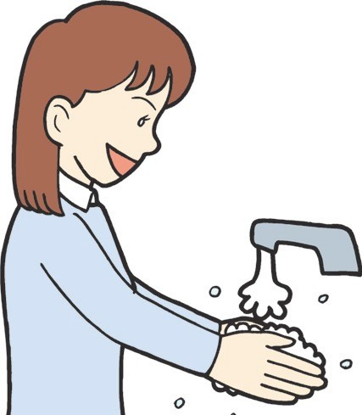Before every meal, all children should wash their hands under running water. Hands of all ages carry germs, and it is best that dirty hands are not in touch with the mouth. Hands may not look dirty, but germs may still be there.

Basic Foods
Serve only foods and drinks that are nutritious. The sim-­‐‑ plest, surestwayistosupplyfoodsformealsusingthe Four Basic Food Groups.

The Milk Group:
w milk or ice cream
w cheese
w soups and custards made of milk

The Bread and Cereal Group:
w enriched or whole grainbread
w cereal
w rice
w macaroni w spaghetti w crackers

The Fruit and Vegetable Group:
w apricots w cantaloupe w oranges w broccoli w carrots w greens
w squash
w sweetpotatoes
The Meat Group: w red meats w fish
w poultry w eggs w cheese

Food Servings
The following is a chart showing the least number of servings of the Four Basic Food Groups for each child according to the amount of time spent in your care.

FOOD SERVINGS
 | Time In Care
Four Basic Food Groups | 5 - 8 hours | 8 hrs or longer
Milk Group | 1 serving | 2 - 3 servings
Bread/Cerea l Group | 1 serving | 2 - 3 servings
Fruit/Vegetable Group | 2 servings | 3 - 4 servings
Meat Group | 1 -2ounces | 2 - 4 ounces

Snacks should also be nutritious. Snacks can include: fresh fruits, raw vegetables, peanutbutter, hard boiled eggs, bread or crackers, ice cream, or milk.

Bottle Feeding
w If you provide the formula for bottle feeding, use a pre-­‐‑mixed, iron-­‐‑fortified formula unless you have been given other instructions by the child’s parents or physician. This formula
helps prevent iron deficiency anemia. w Whencaringforinfants, thepar-­‐‑ ents will usually bring the full bottlesortheformulaingredients.
w Have parents pro-­‐‑ videbabybottlesla-­‐‑ beled with the child’s name.
w If the infant uses a specialformula, have the parents bring enough for each day. Keep the formula re-­‐‑ frigerated.
w Hold infants during feeding. Theyneedthecuddlingand warmththatyoucangiveduringthistime. Chil-­‐‑ dren who drink from bottles while lying down can strangle, getear infections, ordentaldecay. w Afterfeeding, washthebabybottlerightaway. Donotwaitfortheparenttowashitathome. Milk left in bottles will cause bacteria to form. These
germs remain in the bottle even after thorough washing, and the bottle can never be properly cleaned. If itisnecessarytosterilizeabottle, doitat a convenient time, but it still must be washed imme-­‐‑ diately after feeding. Rinsing the bottle in hot water isnotenough.

Dental Care
The importance of primary (baby) teeth is being stressed more and more by dentists. The primary teeth have sev-­‐‑ eral functions including the following:
w Theyhelpinchewingfoodandcontributetodi-­‐‑ gestion.
w They contribute to facial development and ex-­‐‑ pression.
w Theyallowspaceforpermanentteethtocomein. When a primary tooth is lost too early, teeth on ei-­‐‑ ther side may take up some of the space. This may
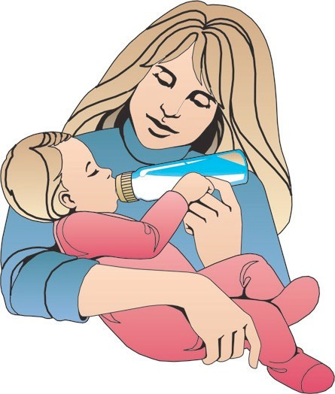result in an eventual shift of all the child’s teeth.
w Theyhelpachildtalkclearlyandef-­‐‑ fectively.

Careof Teeth
Care of an infant’s primary teeth should begin as soon as teeth appear. A baby’s first tooth may be expected byapproximatelysixmonthsofage.
Itwillbethefirstof 20 primaryteeth appearing between six and 24 months of age. Some of them will
remain in the mouth until the child is around 12 years old.
w Asthechildgrowsanddiffer-­‐‑ ent stages of training are started,
help the child in routine care of
teeth.
w Veryearlyinachild’strain-­‐‑ ing, teach the basics of good
teeth care. Habits learned as children will probably last through life. Dental health habits should be taught along with feeding, washing, and dressing.

w Helpful dental habits include:
-­‐‑ eating a balanced diet every day.
-­‐‑ brushing after every meal and snack. If brush-­‐‑ ing is not convenient, rinse the mouth well with water.
-­‐‑ visitingthedentistwhenchildrenarebetween 2 and 4 yearsold. Continuevisitsatregularin-­‐‑ tervals.

Brushing the Teeth
Thetoothbrushdoesthesamethingthatraw, coarse foods did for the teeth and gums of primitive people. It removesleftoverfoodinwhichacid-­‐‑producingbacteria live.
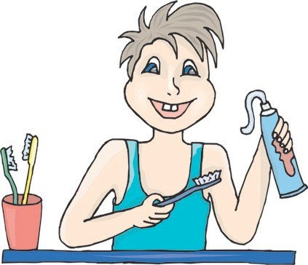w Tooth decay is caused by a chemical reaction between bacteria, sugar, and acid in the mouth. Brushingtheteethreducestoothdecay.
w Theacidsthatcausedecayaremostactive right after meals. The sooner the teeth are brushedaftereating-­‐‑from 10 to 15 minutes after meals-­‐‑the better the results in fighting tooth
decay.
w For effective tooth brushing:
-­‐‑ Brush rightafter eating.
-­‐‑ Use a circular wrist motion to brush front and back of teeth, brushing from the gum line to-­‐‑ ward the biting or chewing surfaces.
-­‐‑ Brush the top and bottom chewing surfaces with a back and forth scrubbing motion.
-­‐‑ Brush in a definite order. For example, start at upper left back corner and finish with lower right corner.
-­‐‑ Rinse the mouth after brushing.
-­‐‑ Use the proper size of toothbrush and grade of bristles. Replace toothbrushes when they become worn.

Maintaining Sanitary Conditions
w Children should have their own toothbrushes. Each toothbrush should be rinsed well before and afteruse.
w Each toothbrush should be stored by itself and in a place the child can reach.
-­‐‑ Ifthereisroomfortoothbrushholders, the toothbrushes can be hung up to help them dry.
-­‐‑ Children can have paper cups that are changed daily to store their toothbrushes in.
-­‐‑ Toothbrushes can be stored in the plastic con-­‐‑ tainers in which they are bought. However, be surethecontainerhasairholesorthebrushes
willnotdry.
-­‐‑Toothbrushesshouldneverbestoredinone group container.
w Children’s toothbrushes should have their names or color code on them.
-­‐‑ Names can be placed on the toothbrush handle or on the con-­‐‑ tainer.
-­‐‑ If you have only a few chil-­‐‑ dren, use differently colored tooth-­‐‑ brushes for each child.
-­‐‑ Children should be taught to use their own toothbrushes. They should never use any-­‐‑ one else’s.
w Thenumberofchildreninthebathroomatone time will depend on your space.
-­‐‑ Nomorethanonechildatatimeshouldbeat a sink. Children tend to spit on each other while brushing.
-­‐‑ An adult or older child should supervise any child under 3 years of age.
-­‐‑ Children should be taught how to wipe or rinse off the sink after use, and how to clean and replace their toothbrushes.

Daily Health Check

Lookateachchildeverydayforpossiblehealthprob-­‐‑ lems. Youngchildrencatchthingsveryquickly, and contagious diseases can spread to other children quite rapidly. A daily health check can alert you to early signs of illness.
A daily health check can also help you notice when a child is not completely well or is developing another problem afterrecovering from aperiod ofillness. For example, a child who has been out with a cold may seem to be well and return. A few days later, the child may haveunusuallybadbreath, meaningapossiblethroat infection. Or the child may have “runny” ears, indicating anearinfection.

Observations
Each morning when a child first comes into the home or center, youshouldspendafewminutestalkingtoand observing thechild. Getdown on thechild’sleveland exchangeapleasantrysuchas,“Goodmorning.” Ask how they feel or what they did the day before. While you are chatting with the child, you can look very closely for health signs and symptoms.
w Achild’seyesoftentellyouaboutthechild’s health.
-­‐‑ Are the eyes watery or inflamed?
-­‐‑ Do they have a glazed appearance?
-­‐‑ Are the lashes or lids crusty?
w Iftheeyeslook theleastbitunusual, observethe child carefully throughout the day for other indica-­‐‑ tions of illnesssuch as fever, vomiting, ordiarrhea.
w Breathingandbreathodorarealsocluestoa child’s health.
-­‐‑ Is there a deep cough?
-­‐‑ Istherea“rattling” soundwhenbreathing?
-­‐‑ Is the child breathing mainly through the mouth?
-­‐‑ Does the child’s breath have an unusually bad odor?
w Deepcoughingorarattleinthechestandnoisy breathing should be checked with the parents, and
the child may need to see a physician. Often, chil-­‐‑ dren who seem to have recovered from a cold de-­‐‑ velop chest infections which may not be noticed because the child no longer has a runny nose and seems to be feeling so much better.
w Lookforanyrashes, sores, orotherunusualcon-­‐‑ ditions of the skin. These could indicate a contagious condition or one that needs simple first aid.
w Any child who comes to a center or home with frequent bruises, scratches, cuts, or injuries may be anabusedchild. Youarerequiredbylawtoreport these cases to your local police or to the Department of Human Services. Do not speak to the parents about it; let the authorities take care of it for you.
w Other things to look for include:
-­‐‑ Pulling or tugging at the ears, especially after a cold. This may indicate an ear infection.
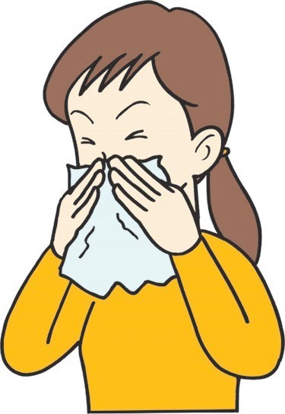-­‐‑ Scratchingattherectum, especiallyduring naptime. This may indicate pinworms. Pin-­‐‑ worms are often overlooked in young children. Discuss irritability, fussiness, or scratching with the parents.

Recording Observations
Anyunusualobservationsshouldbenotedandrecorded in the child’s folder. If the child is ill or showing early symptoms of a medical problem, you will have enough accurately recorded information to give to the parents or medical advisor.
w Ifthechild looksoractsmorethan mildly ill, notify the parents as soon as possible.
w Ifyouhavenoticedandrecordedanyunusual symptoms, such as rectal itching, that continue for up to 10 days, notify the parents.
w You do not need a special form for recording theseobservations. Justuseapieceofpaperand write the child’s name and your observations on it. When you do record a symptom or observation, be sure to date it.
w Often, you will make an observation about a child’s health at times other than the daily screening. Record this information as soon as it is convenient.

Periodic Screening and Reporting

You are in an unusually good position to notice children who have health problems. You see each child for several hours a week while a physician only sees a child for a shorttimeduringanexamination. Poorcoordination, speech problems, excessive tiredness, and withdrawal from others are but a few of the things which you may see in a child before a physician or parents do.
For example, Dee was a 3-­‐‑year-­‐‑old first child who did not speakwellandfrequentlydidnotanswer. Hisparents thought this was because of his age. The day-­‐‑care teacher, however, knew that other children were answer-­‐‑ ingquestions, respondingtoeachother, andspeaking much more clearly than Dee. She wrote down her obser-­‐‑ vationsandtalkedtothecenternursewhoagreedthat there was probably a problem. After talking to the parents and explaining the observations, the parents had Dee checked by a physician who specialized in hearing problems. They found that Deehad ahearing lossand could be helped through the use of a hearing aid.
The critical importance of the child-­‐‑care person in ob-­‐‑ serving and referring children with possible problems cannot be overstated. Children are not aware of problems and may not be able to tell adults. Parents may not recog-­‐‑ nize a special problem, because they see only their child. Because you see several children everyday, you may be more alert to early symptoms.
Periodic screening is an important part of your work withyoungchildren. Periodicscreeningmeansrecording things you observe about a child. To be consistent in observing allthe children, use a checklist.
Lack of progress over time is a sign of a physical or developmental problem. Observe children during the first few weeks they are with you and again after a few months. Also, anytimeyouthinktherehasbeensome type of change in the way a child is acting, use a checklist or make notes of observed behaviors throughout a day. (Do not choose one of the child’s bad days.) Examples of notes are “worked a five-­‐‑piece puzzle without help,” “could not tell that the domino with five spots had more spots than the domino with three spots,” or “squinted all the time while drawing with crayons.”

Points to Remember
Do periodic screening every few months for each child in yourcareandrecordyourobservations.
Each record should include information on each child for the areas of:
w generalhealth,
w motor skills development, vision,
w hearing,
w speech and language, behavior, and
w learning.
If you use a checklist, noting the appearance or behavior that lead to your checklist assessment will make future comparisons more meaningful. Most children will not have any problems. However, keep the records of screen-­‐‑ ings in their files. The next time you screen the child, you can compare to see if any changes have occurred.
If you feel a child is having a problem, share the informa-­‐‑ tionwiththechild’sparents. Whenachildisreferredto another professional such as a physician, speech thera-­‐‑ pist, or psychologist, ask the parent’s permission to give the information to the person who will examine the child.
Health
Whencheckingforhealthproblems, lookfor:
w visible signs and symptoms of illness or disease,
w complaintsofpainorillness, or
w behavior that indicates health problems.

Points to Remember
When you look for health problems, distinguish between those that are chronic, and those that are acute. A chronic diseaseisonethatoccursagainandagainorlastsalong time, even for life, such as a heart condition. Some problems, suchasarunnynoseorirritability, areonly problems if they happen often or go on for a long time.

Other health problems are serious if they occur suddenly or have severe symptoms. Acute problems such as high fever, vomiting, and a rash which could indicate diseases suchasscarletfever, shouldbereferredimmediately.
Health observations must be made over a period of time. However, check all children for signs of illness each day when they arrive.
What to Do
If you suspect that a child has a health problem, whether long-­‐‑ orshort-­‐‑term, talkwiththeparents. Ifyouareina center, check with your supervisor about referral proce-­‐‑ dures.
Parents should always be contacted before a child is referred to any person or agency outside of your facility. Becauseachild’shealthisatstake, youshouldinform parents that a physician should be seen as soon as possible.
A pediatrician isamedicaldoctorwhospecializesin treating children. Some parents prefer to take their child toa familyphysician whotreatsadultsaswellaschil-­‐‑ dren. Eitherwillexamine the child carefully and give
treatment for illness. If the doctor finds that the child has a serious chronic ailment such as heart disease, referrals will be made to other physicians and specialists as needed.
Children with an infection should stay at home until they no longer have fever. There is danger that other children mightalsogetsick. Chronically illchildren may need special treatment at school. Talk to the child’s parents or doctor to see whether medication must be taken or activ-­‐‑ ity at school should be limited. All instructions should be in writing.
If the child must take medicine at school, be sure the bottle or box is labeled with the name of the medicine, the child’s name, and the amount and time of medica-­‐‑ tion. All medicines should be placed out of the reach of childreninasafelylockedcupboard.
If you have a child with a specific health problem like heart disease, find out the signs or problems you need to look for. Be sure that you know how to reach the parents of the chronically ill child, and be certain to let them know if you observe changes in the child’s condition.

Health Check Form

Nameof Child: Date:

On the items listed below, check those that apply. For those checked, give a description of what you observed (where located; appearance; sizeofsore, injury, oraffectedarea; actualbehaviors; frequency; etc.

SKIN
itching or rash sores wounds or injuries cuts and bruises slow to heal

HEAD, MOUTH, and NECK
lice sores on head bad teeth

ARMS and LEGS
bluish tint to nails difficultyusingarm, leg, hand walksontiptoes orstifflegged

DIET and EATING
extremely undeweight or overweight (list height and weight) excessivehungerorthirst eats non-­‐‑foods

RESTROOM BEHAVIOR
frequent diarrhea or constipation frequent or painful urination poor bladder control scratchinganalarea

BEHAVIORS THAT SIGNIFY HEALTH PROBLEMS
frequent absence from school excessive fatigue, irritability lack of energy, listlessness

Vision
Whencheckingforvisionproblemslookfor:
w visible signs of something wrong with the eyes
w behaviors that indicate vision problems.

Points to remember
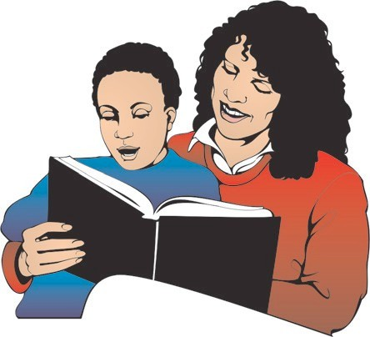Vision is very important, but often, children with vision problemsarenotidentifieduntiltheybeginreadingor evenlater. However, evenveryyoungchildrenwitha vision impairment will show some conditions and pat-­‐‑ terns of behavior that indicate a problem. For example, a child whose vision is blurred or fuzzy will often squint or peer intently at objects in an attempt to see better.
Manyday-­‐‑carecentersand some community organizations provide a vision screening test. Thevisionchecklistisnotasubstitute for vision screening which should be provided annually for all children over the age of 4. Vision screening does not identify all vision problems. Using a checklist to
identify the behavior-­‐‑the way achildacts-­‐‑thatpointsout possible problems can be of helptoparentsandphysi-­‐‑ cians.

What to do
Children who may have vision problems must be eferred for a formal eye examination given by an ophthalmologist or an optometrist. This is done through thechild’sparents.
An ophthalmologist is a medical doctor specializing in eye diseases and other vision impairments, who can per-­‐‑
form surgery and prescribe medicines as well as pre-­‐‑ scribeglassesandcontactlenses.
An optometrist is a non-­‐‑medical doctor who examines theeyesfordiseases, muscledisturbance, andvision impairment, and prescribes glasses, contact lenses, and vision therapy. An optometrist cannot treat diseases of the eye, but if there is evidence of eye disease, the optometrist will refer the child to a medical doctor (oph-­‐‑ thalmologist).
An optician is a licensed practitioner who grinds and fits lensesandadjustsandfitseyeglassesframes. Anoptician
does notexamine eyes.
You can help prepare children for eye examinations by letting them tryonglassesframesandtelling them what will happen and what they will be expected to do. If
there is a vision screening program in your center, you can help prepare children by explaining what they are ex-­‐‑ pected to do. Usually the center nurse or health aid does the vision screening.
Ifachildbeginswearing glasses, ask the parents whether the child needs any
specialhelp. Visually impaired children need work areas that are well-­‐‑lighted and free from glare. Seat them wheretheycanseeclearly. Ifthechildistowearapatch or eyeglasses, see that the child does so. Help the child to accept wearing an eye patch or glasses by admiring them andpreventingtheotherchildrenfrom makingfun.

Vision Checklist

Red, swollen eyelids Crusts or sores on eyelids Red, watery, orcloudyeyes Drooping eyelids Eyes do not appear to work together (describe)

Peers intently or squints frequently Leansunusuallyclosetowork Tilts head or closed one eye Bumps into things or trips over objects Complains of the inability to see well

Hearing
Whencheckingforhearingproblemslookfor:
w visiblesignsofearproblems, or
w behaviors that may indicate hearing loss.

Points to Remember
Children learn to speak and understand language through hearing. Through language, they learn aboutthe world and their place in it.
Children with even a mild hearing loss may miss much of what is said and much that happens in the world around them. They may not learn to identify sounds, and often do not understand directions. A child with a hear-­‐‑ ing lossmay nothearyou when you call, orifthelossis severe, hear the horn of a car. Observe children who seem uncooperative and disobedient for hearing prob-­‐‑ lems. Good hearing is essential, but often the hearing impairedchildisnotidentifiedbecausenoonehasno-­‐‑ ticed the behaviors thatshow the problems.
Some children have tubes in their ears because of earlier ear problems. Keep this information in the child’s school health record. It is important for teachers to know if
children have tubes, especially if swimming is part of the program. Havetheparentsgivewrittenpermissionfor
the child to swim, and follow the doctor’s instructions regardingtheuseofearplugs.
Manyhearing-­‐‑impairedchildrenhavespeechproblems. Every child with a speech disorder should be checked for possible hearing loss.
Hearing tests with an audiometer are given by the public schools for children who are 6 or older. Some cities have volunteer groups which do screening for younger children. Talk with the state or local health department or licensing representative to find out who does hearing tests for the children in your care.
What to Do
If you think a child may not hear well, talk to the child’s parents. Explain why you think there may be a problem andasktheparentstotakethechildforaprofessional hearing examination.
An otolaryngologist is a medical doctor who specializes in diseases of the ear, nose, and throat.
An otologist is a physician who specializes in diseases of the ears only. Any child with suspected ear disease should be seen by a physician.
If there is no ear disease but you suspect a hearing loss, the child should be examined by an audiologist, a professional with training in the management of the

non-­‐‑medical aspects of hearing impairment, who tests hearingandhearingskillsandrecommendshearingaids and special auditory training. Send a copy of the check-­‐‑ listtothephysicianoraudiologistforthechildrenyou refer. This will provide information about unusual be-­‐‑ haviors you have observed.
If a child has a hearing loss, you will want to get infor-­‐‑ mationfromthepersonwhoexaminesthechild. Ask how severe the child’s hearing loss is, whether both ears are affected, and how the child may be affected. If the
child is to wear a hearing aid, ask how long it should be worn each day. Check to see that the child wears the aid, that it is turned on, and that the aid is operating properly.
The audiologist can tell you about the hearing aid, how it works, and what to do in case of difficulty. If the child falls behind the other children, either in language or learning development, seek advice from a trained teacher of the deaf or a speech pathologist. The hearing-­‐‑impaired childmayneedadditionalhelpfromtheseprofessionals.

Hearing Checklist

Complains of earaches Tugs, pulls, or scratches at ears Drainage or strong odor from ears Excessive wax, dirt, or foreign object (bead, insect) in ear Does not react to sudden noises Usesgesturesinsteadoftalkingtocommunicate Watches speaker’s face very closely Does not respond when spoken to from behind or from across the room Asks for frequent repetitions (Huh? What?) Unusual voice: extremely soft unusually loud monotone

Associated Problems:
Frequentcoldsorsore throats No speech Dizziness, nausea, or unsteadiness Changes in behavior after absence or illness Reports of ringing or whistling in ears Signsoffrustration: tempertantrums irritability distraction

Speech
Whencheckingforspeechproblems, listenfor:
w child talking like a much younger child,
w child having difficulty understanding or express-­‐‑ ingideasthroughspeech,
w childwhoishardtounderstandordoesnot speak clearly, or
w childwhohaslittleornospeech.

Points to Remember
Learning to talk is one of the most important achieve-­‐‑ ments of young children. During the preschool years, childrengraduallyuselanguagemoreandmoreto expresstheirneedsandfeelings.
While 2-­‐‑year-­‐‑olds may cry if another child takes their ball and may try to grab it back, 4-­‐‑year-­‐‑olds may say, “That’s mine, giveitback. Teacher, hetookmyball.” Thechild whose speech is delayed (talks like a much younger child) or is hard to understand can become very frus-­‐‑ trated over the inability to talk to others.
As children approach elementary school age, they are expectedtolearnmoreandmorelanguage. Ateacher maypointtoashelfandsay,“Bringmethatbook,” toa 3-­‐‑year-­‐‑old. To a 5-­‐‑year-­‐‑old, the teacher may say, “Bring me the book from the top shelf of the bookcase next to mydesk.” Thechildwhohastroubleunderstandingwill fall further and further behind in learning. The child may also become withdrawn or appear disinterested.
Young children are sometimes aware that they have speechproblems. Otherchildrenmayhavelaughedat
their mispronunciations or stuttered words. The child may then hesitate to speak. Adults, parents especially, need to realize the importance of the child’s understand-­‐‑ ing and use of language in order to see that children who haveproblemsgetspecialhelp.
Young children’s speech should not be compared with adult’sspeech. Allyoungchildrenleaveoutsounds, repeat words, and put words in a different order while they learn to speak. A young child is said to have a speech problem only if the problem is so different from other children’s of the same age that it calls attention to itself or interferes with the ability to communicate.

What to Do
Parental permission for speech testing is not required if youhaveaspeechtherapistinyourcenter. Ifnot, you probablywillwanttheparentstotaketheirchildtoa clinic for a speech test.
Speech evaluations are given by a speech pathologist (speech therapist), a professional who specializes in the diagnosis and treatment of speech and language disor-­‐‑ ders.
Speech therapy services may be available through a local speech and hearing clinic, hospital, university, or some other agency.
The speech pathologist will evaluate the child’s overall language development and hearing as well as speech. The child may be recommended for speech therapy or other testing. The speech therapist can provide you and the parents with suggestions for working with the child in the classroom or at home.

Speech/Language Checklist

NEVER SPEAKS:
makes no sounds makessoundsbutnowords does not seem to want to talk

SELDOM SPEAKS:
seldom speaks to anyone
will speak in some situations but not in others. Explain

IS HARD TO UNDERSTAND:
speech cannot be understood tonguesticksoutwhentalking frequently repeats words or sounds unusual voice. Explain

TALKS LIKE A MUCH YOUNGER CHILD:
speaks in shorter sentences or phrases than other children of the same age leaveswords outofsentences does not know the names of common objects

SEEMS TO HAVE DIFFICULTY UNDERSTANDING SPEECH:
doesnotfollowdirections; easilyconfused
respondsbetterwhengesturesareused

SEEMS TO HAVE DIFFICULTY EXPRESSING IDEAS THROUGH SPEECH:
usesgesturesinsteadofwords starts to say something but stops as if looking for the right word gives incomplete or wrong answers to questions he/she should understand repeats questions orechoes (repeats whatothers say without meaning)

Motor Skills
When checking formotorskills problems look for:
w gross motor skills problems: difficulty with walk-­‐‑ ing, running, throwing, and other large movements, and
w fine motor skills problems: difficulty using the hands for small, close work.

Points to Remember
Young children use their body movements as much as their eyes and ears to help them learn. They pick things up, shake them, swing them around, and do many other physicalthings with objects they are learning about.
Childrenwithmotorskillsproblemsmaynotdothese things, and their learning may be slowed. Because most preschoolchildrenarestillsomewhatuncoordinated, the young child with motor skills problems may not be noticed without careful observation.
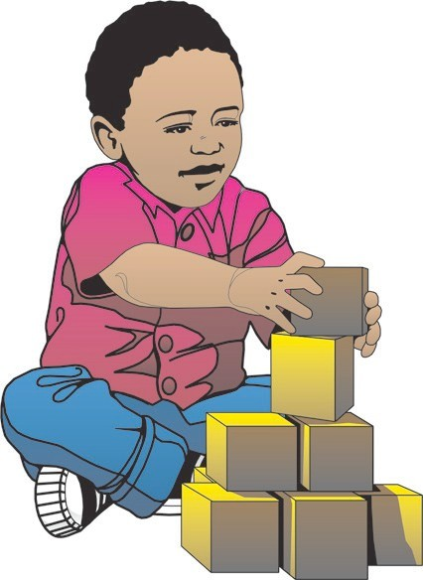The child with motor skills problems has difficulty with movements and coordination. Gross motor skills activities involve move-­‐‑ mentsofthebodyandlimbs. Gross motor skills are needed for climbing, jumping rope, dancing, and other
physical activities.
Fine motor skills tasks involve smallmusclecontrol, especially of the hands. Fine motor skills abili-­‐‑ ties are needed for many activi-­‐‑ ties, including coloring, cutting, workingpuzzles, andstringing beads, as well as for writing.
Most fine motor skills activities also require good visual abilities. The child’s eyes and hands must work together. This is called eye-­‐‑hand coordination. Children use their eyes as well as their hands when they string beads or draw circles.

What to Do
Children having trouble with activities that most of the other children do should be referred to a pediatrician or a family physician. The doctor may then refer the child to some other medical specialist, such as an orthopedic or bone and joint surgeon. Also, if a child needs special-­‐‑ ized training in motor skills, the doctor may refer the childfortherapyfromaphysicaltherapistoroccupa-­‐‑ tional therapist.
Children with motor skills problems may have trouble with many kinds of activities. Encourage the children to try motor skills activities, and give them motor skills tasks that are easy enough to do. If they are embarrassed about being clumsy on the playground, organize some quiet motor skills games with only a few children.
Rolling or bouncing a ball among three or four children is one activity that can help develop motor skills.
Simple fine motor skills tasks might include putting objects in small containers or “drawing” with a finger dipped in paint instead of using a crayon. You can get other suggestions from the physician or therapist who is working with the child.
Some children in your class may wear corrective shoes. If so, write this down and note whether or
not the child may go barefoot.

Motor Skills Checklist

On each of the following items, the child should be compared with other children of the same age.

Unusually clumsy or awkward in using legs or feet.
poor posture (describe) feet: toes in (pigeon toed) toesout walks on tiptoes much of the time stumbles or fails frequently walks stifflegged legs twitch, jerk, tremble, or shake

Hasextremedifficultyin:
running skipping kickingaball
hopping jumping other

Unusuallyclumsyorawkwardinusingarms.
complains of tiredness or pain in arms after physical exercise
arms twitch, jerk, tremble, or shake

Hasextremedifficultyin:
throwing catchingaballswingingarope moving arms in a circle other

Does not use toys or objects well. Has extreme difficulty in:
pickingupobjectswiththumbandforefinger stacking one-­‐‑inch cubes putting a peg in a hole hitting a peg with a hammer stringing beads cutting with scissors (older children only) coloring within lines (older children only) holdingpencilorcrayon eating with a spoon and fork

Behavior
Whencheckingforbehaviorproblemslookfor:
w frequent or extreme undesirable or unpleasant behavior, or
w difficulty getting along with others.

Points to Remember
At one time or another, all children act in ways which annoy, anger, or worry adults. Children who are tired or sickmaycry, whine, andrefusetoparticipate. Allchil-­‐‑ dren fight over toys, more frequently at some ages than at others. However, some children seem to spend most of their time and energy disrupting the classroom. Others never seem to adjust and are fearful and withdrawn.
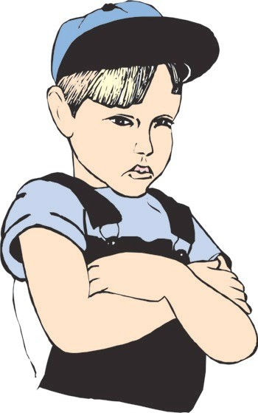Children who have undesirable or unpleasant behavior much of the time may have problems. Such problems can interfere with a child’s learning and the child may become disliked by the other children. These children are notusuallyhappy. Theyneedhelpwiththeirproblems,
andyouneedhelpunderstandingtheirproblems. Care-­‐‑ ful observation and referral to the right professionals is veryimportant. Also, itisnotalwayseasytoseparate learning problems from behavior problems. The symp-­‐‑ toms are often the same

What to Do
Ifyouthinkachildishavingbehavioralproblems, the child should be referred to the early childhood program for children with special needs at your local public school. Theseprogramsaredesignedtoidentifychildren with special needs and are available at no cost to the parent.
Beforeyoumakeanyreferral, itisveryimportantthat you talk to the parents. You must have their permission torefer, andtheymaybeabletogiveyousomeunder-­‐‑ standing about why the child seems to be having behav-­‐‑ ior problems. There may be some upsetting situations in the home, such as an illness or a conflict between the parents which are affecting the child. The child may be imitating the unpleasant behavior of an adult. For example, a child who hits others in school may live with an adult who hits others.
Tohelpthechildwithbehavioralproblems, youwill need the advice of other professionals. The person who evaluates the child should give you information about the special needs of the child.
Thechildwillverylikelyneedextraattention, andyou cangiveitthroughoutthenormalday. Stopandtalkto the child and look at what he or she is doing. Take special care to give the child attention for working hard and playingwellwithothers, notjustwhensomethingbad has happened. Ignoring a child who is doing well and giving attention to misbehavioris rewarding poor behav-­‐‑ ior with attention.
You maywantto setupa“quietcorner” forchildrento go or work in when they are feeling restless or frustrated. If the child’s behavior is very disruptive and difficult for you to dealwith, talk to apsychologistorotherprofes-­‐‑ sionalpersonaboutwaysofhelpingthechildlearnself control.

Behavior Checklist

Checkobservedbehavioranddescribesituationswhereitoccursandhowfrequently.

Undesirable or unpleasant behavior:
crying tantrums fearful anxious tense withdrawn seldomsmilesorlaughs frequent changes of mood

Destructive behavior:
tries to hurt self triestohurtotherchildren
tries to hurt adults tries to break objects or toys

Sleeping problems:
walksinsleep afraid to close eyes
bad dreams wets bed

Problemsgettingalongwithotherchildren:
hitsorfightsphysicallywithotherchildren does not cooperate; bothers or interferes with others avoids other children; does not interact with them other

Problemsgettingalongwithadults:
avoids adults; does not interact with them clingstoadults hits or fights with adults

Learning
Whencheckingforproblems inlearning, look for:
w unusual slowness or immaturity in all areas of learning,
w uneven development in learning, and ·∙ signs of stress in learning situations.

Points to Remember
It is extremely difficult to clearly identify learning prob-­‐‑ lems in children under the age of 4. Children vary so much in their development and learning abilities before this age that it is usually best to wait and watch carefully. However, when 4-­‐‑ and 5-­‐‑year-­‐‑olds are behind their friends, theymayhavelearningproblems.
Your concern with academic skills will depend on the age ofthechildren. Youmaycareforchildrenwhoseemto have difficulty picking up basic skills they will need for later learning. For example, a preschool child may not be abletositstilllongenoughtolistentoastoryormaynot be able to put a puzzle together when the other children in the class can. With school-­‐‑age children, your concern willbe whetherreading, writing, and arithmetic arebeing learned.
It is important that children with learning problems be identifiedearlysothattheycanbegivenspecialhelp before they begin failing in school.
The cause of learning problems in young children cannot always be determined, and it is not right to label the childas mentallyretarded orhaving a learning disability. Labels do not tell much about how a child learns or how to teachthem.

What to Do
If you think a child has learning problems, there may be severalprofessionalsinyourcommunitywhocould diagnose and plan special help for the child.
A psychologist or psychometrist can give the child tests whichcouldhelpidentifytheproblem.
An educational diagnostician or resource teacher could planactivitiesyoucouldusewiththechild. Aresource teacher might also be able to work with the child for part oftheday.
Askyourcenterdirector, licensingrepresentative, school district, orlocal United Fund organization to recommend a good outside agency. Always consult parents before a referralismade.
Ifachildinyourclasshaslearningproblems, youwill want to know what special activities you can do to help the child learn. Talk to the person who hastested the childto find outhow you canhelp. You willneed the parents’ permissiontodothis.
The child may need a quiet place to work alone. Children with learning problems may be more aware of their failures than adults realize. All children need to feel they can succeed and can learn. Changes in behavior can only begin when you give the children tasks at which they can succeedandbepraisedfortheiraccomplishments.

Learning Checklist

Check problems and indicate how frequently.
Unusual slowness or immaturity in learning. Compared with other children of the same age, this child does the following activities with much less skill:

playingwithblocksandpuzzles doing art activities playing with one ormore children lookingatbooks listening to a story doingfingerplaysandsinginggames other uneven development. Child seems to do well in some activities but not in others. (Explain)

signs of stress in some learning situations showslittleinterestinsomeactivities.(Whichones?) becomes tense, hypereactive, or frustrated during some activities (Which ones?)

refusestotry(Explain) asks for more help than other children seldomorneverfinishes

