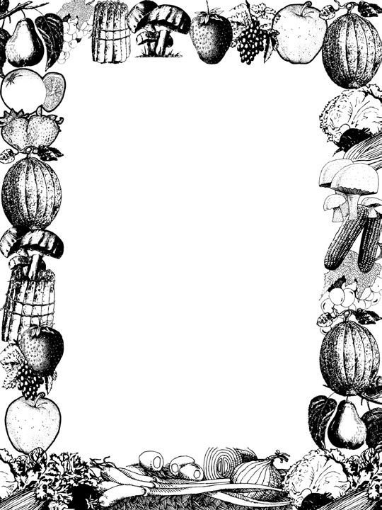

MY KIDS WON’T EAT THAT!

CHILD AND ADULT CARE FOOD PROGRAM
WWW.CACFP.ORG

Did you know 90% of Americans fail to eat the recommended amounts of fruits and veg- etables? See the chart below which lists the recommended amounts according to age and sex

MyPyramid Fruits and Vegetables
Recommended Amounts

Food Program Minimum Portions of Fruits and Vegetables
WOMEN
Age | Fruits | Vegetables
19-30 | 2 cups | 2 1/2 cups
31-50 | 1 1/2 cups | 2 1/2 cups
51 + | 1 1/2 cups | 2 cups
GIRLS
2-3 | 1 cup | 1 cup
4-8 | 1 cup | 1 1/2 cups
9-13 | 1 1/2 cups | 2 cups
14-18 | 1 1/2 cups | 2 1/2 cups

MEN
Age | Fruits | Vegetables
19-50 | 2 cups | 3 cups
51 + | 2 cups | 2 1/2 cups
BOYS
2-3 | 1 cup | 1 cup
4-8 | 1 1/2 cups | 1 1/2 cups
9-13 | 1 1/2 cups | 2 1/2 cups
14-18 | 2 cups | 3 cups

Breakfast
1-2 years ¼ cup
3-5 years ½ cup 6 – 12 years ½ cup

Lunch/Supper
1-2 years ¼ cup
3-5 years ½ cup 6 – 12 years ¾ cup

Snack (Optional)
1-2 years ½ cup
3-5 years ½ cup 6 – 12 years ¾ cup
Above numbers are based on activity levels of less than 30 minutes per day. For speciﬁc recommendations based on age, sex and activity levels go to the website www.fruitsandveggiesmatter.gov
1 What Counts? No matter what the form,
4
fresh, frozen, canned, dried, juice – all varieties of fruits and vegetables count toward your daily recommendation. Choose fruits without added sugar or syrups and vegetables without added salt, butter or cream sauces. Although 100% fruit or vegetable juice counts toward your daily recommendations, the majority of the total daily amount of fruits and vegetables should come from whole fruits and vegetables to help you get enough ﬁber.
2

What counts as 1/2 cup?

1 small pepper 1 small ear of corn
1 small banana
- broccoli ﬂorets

16 grapes

- baby carrots or 1 medium carrot

1 cup leafy greens

What counts as a 1 cup?

1 large banana
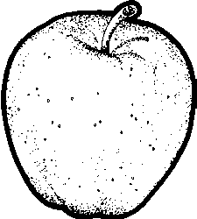 1 medium apple 1 large sweet potato 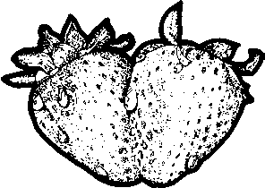 8 large strawberries
1 large orange
12 baby carrots or 2 medium carrots

2 cups spinach leaves
2 large stalks of celery

Just the Facts – On Fruits and Veggies

Heart Attack Risk
Two Harvard studies show for every extra serving of fruits and vegetables that par- ticipants added to their diets, their risk of heart disease dropped by 4 percent.

People who averaged 8 or more servings of fruits and vegetables per day were 30% less likely to have had a heart attack or stroke than those who averaged less and 1.5 servings a day.

High Blood Pressure
People with high blood pressure who followed a diet that was rich in fruits, vegetables, and low-fat dairy products and that restricted the amount of saturated and total fat reduced their systolic blood pressure (the upper number of
a blood pressure reading) by about 11 mm Hg and their diastolic blood pressure (the lower number) by almost 6 mm Hg - as much as medications can achieve.

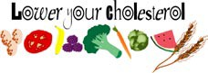

Cholesterol
Men and women with the highest daily con- sumption of fruits and vegetables (more than
4 servings a day) had signiﬁcantly lower levels of LDL (bad) cholesterol than those with lower consumption.

Cancer Prevention
There is limited evidence for a cancer preven- tive effect of consumption of fruit and of veg- etables for cancers of the mouth and pharynx, esophagus, stomach, colon-rectum, larynx, lung, ovary (vegetables only), bladder (fruit only), and kidney.

Eye Health
Eating plenty of fruits and vegetables also keeps your eyes in good shape. Fruits and vegetables help prevent two common age related eye diseases - cataract and macular degeneration - which afﬂict millions of Ameri- cans over age sixty-ﬁve.

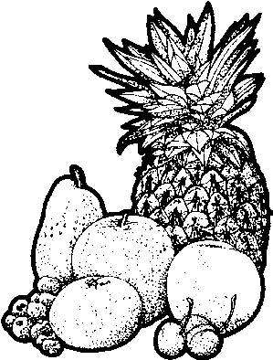Serve them and they will eat them
Studies show that children will eat more fruits and veg- etables if parents and care- givers make them available as part of meals and snacks.

Food Preparation Increases Consumption Elementary age children who completed fruit and vegetable food preparation activities with their families were found to have an increased consumption of fruits and vegetables after the activity.

Fruits and Vegetables are Affordable
More than half of the 154 different forms of fruits and vegetables analyzed by USDA cost less than 25 cents per serving. That’s a bar- gain compared to other snack foods. (1999 data)

Enjoy a Variety of Colors
No one food contains all the nutrients your body needs. Eating fruits and vegetables of different colors; green, orange, red, yellow, blue/purple and white gives your body a wide range of nutrients.

Veggies for Kids
Some children are reluctant to eat or even try vegetables. There are several possible explanations for why children might respond this way.

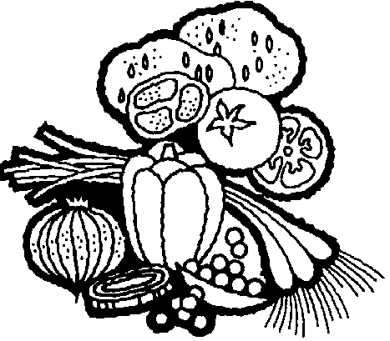Children are not offered vegetables to eat. Some families
do not offer vegetables with meals either because children have refused them in the past or because parents do not eat vegetables themselves. Offer fruits and vegetables with every meal and let the children see you enjoying them. Children need many exposures to unfamiliar foods before they are willing to try them. Eventually they will be willing to try them as long as they are still available.

Children have been forced to eat vegetables. If children have been forced to eat vegetables in the past they will be reluctant to eat them because the experience was unpleasant. Caregivers should continue to offer vegetables at meals but leave the decision about how much and whether to eat them up to the child.

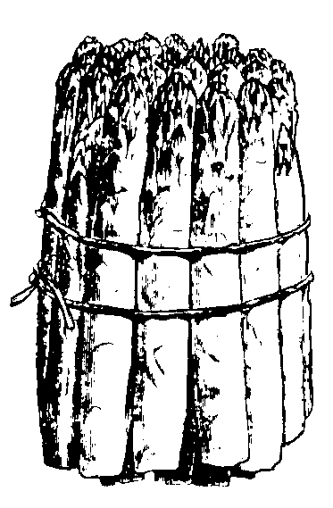Children have super sensitive taste buds. An older adult has 3000 taste buds; a child has about 10,000. Coupled with a natural craving for bland and sweet foods, this can make vegetables a tough sell. Some vegetables have a bitter ﬂavor which children may be sensitive to. Try offering stronger ﬂavored vegetables with a dip or sauce or sprinkle with a small
amount of sugar to counteract the bitter ﬂavors. Most important - don’t give up. Children’s tastes do change over time. Something they refuse today could be one of their favorite foods six months from now.
The Tongue
BITTER
Not many
taste buds
Taste cells are clustered in taste buds on the
tongue. The taste buds which contain taste re- ceptor cells are located at the base of the visible bumps on the tongue know as papillae.
SWEET

Fruits and Veggies - More Matters
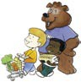The message is clear – no matter how many servings of fruits and vegetables currently eaten, everyone can beneﬁt from just one additional serving each day.

Involve the children and the family in the selection process
If a ﬁeld trip to the supermarket or having the kids tag along on the next grocery trip is not an option, use grocery store advertisements or pictures of different fruits and vegetables to allow the children to choose some to try. Try different serving ideas to ﬁnd one that most everyone enjoys.

Create a positive association with creative names
Fun sounding names for fruit and vegetable offerings does lead to increased consumption. In a recent study researchers found that the number of preschoolers eating peas doubled when regular peas were offered as “power peas”. The same thing happened with dinosaur trees (broccoli) and rainforest smoothie (tomato juice).

Offer fruits and vegetables at snack frequently
While fruits might be considered a common snack, vegetables are less commonly served for snack. Some ideas to consider: Rainbow veggies and dip; Veggie & cheese tortilla roll-up; Breadsticks with Zesty Tomato Sauce; Power Fruit Smoothie.

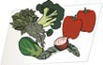Let the child help prepare them
Small children can help with simple preparation tasks such as washing the skin of fruit before cutting and peeling or tearing salad greens into small pieces for a mixed salad. Even the process of stirring together
a variety of chopped fruit and squirting with a little bit of fruit ﬂavored yogurt helps children feel like they’ve prepared something delicious.

Store cut up vegetables at eye level in the refrigerator
Wash, peel and cut raw vegetables and place them in clear plastic containers at eye level in the refrigerator for easy snacks.

Mix together single servings of fruit or vegetables
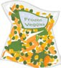Small amounts of leftover vegetables can be frozen and added to soups, salads, stews or scrambled eggs. Blend leftover fruit chunks with fruit juice and yogurt for a tasty smoothie or add to a mixed green salad or coleslaw.

Enhance your mixed dishes with additional vegetables
Boost nutrition in mixed foods by adding small amounts of shredded or pureed vegetables to foods such as spaghetti sauce, soups, meatballs or meatloaf and rice. Use low sodium vegetable juice as a base for soups instead of chicken or beef broth.

Plan activities around the theme of fruits and vegetables
Reading a story about vegetables or participating in a craft activity using fruits and vegetables makes fruits and vegetables more familiar to the children. The more familiar fruits and vegetables are the more likely children are to eat them.

Snack Cost Comparison
Serving fruits and vegetables at snack is an excellent way to increase consumption and help children meet their daily fruit and vegetable requirements. The following is a cost comparison between fruit and vegetable snacks in the column on the left to some commonly served snacks on the right. Which fruit and vegetable snacks could you consider serving in your day care?
Remember when it comes to fruits and vegetables more matters!

PNB w/ celery Apples | $ .25
Baked Potato Cheese | $ .25
Applesauce Cinnamon Toast | $ .30
Cottage Cheese Pineapple | $ .31
String Cheese Apple Slices | $ .32
Fruit Cup Milk | $ .32
Yogurt Bananas | $ .33
Fruit &  Cheese Kabobs | $ .35
Baked Sweet Potato Milk | $ .38
Corn & Tomato Salsa Tortilla Chips | $ .38
Yogurt in  Fruit Smoothie | $ .42
Fruit Pizza (Grahams) Milk | $ .42
Kiwi Yogurt | $ .42
Cereal Mix Grapes | $ .55
Raw Veggies Cottage Cheese Dip | $ .64

Tortilla Chips Cheese | $ .32
Pretzels  Orange Pineapple Juice | $ .36
Oreos Milk | $ .36
Animal Crackers Cran-Apple Juice | $ .37
Chocolate Chip Cookie Milk | $ .40
Chocolate Grahams Milk | $ .40
Chex Mix Milk | $ .41
Pop-Tart® Milk | $ .42
Chocolate Milk  Peanut Butter Grahams | $ .43
Ritz Bits  100% Juice Punch | $ .45
Hi Ho’s with Cheese Milk | $ .51
Doughnut Apple Juice | $ .51
Goldﬁsh Crackers String Cheese | $ .52
100% Juice Punch Rice Krispie Bar | $ .56
Granola Bar Milk | $ .65

Safe Storage of Fresh Fruits and Vegetables

Preparation Tips for Fresh Produce
Buying Tips for Fresh Produce
- You can help keep produce safe by making wise buying decisions at the grocery store.
- Purchase produce that is not bruised or damaged.
- When selecting fresh cut produce - such as a half a watermelon or bagged mixed salad greens - choose only those items that are refrigerated or surrounded by ice.
- Bag fresh fruits and vegetables separately from meat, poultry and seafood products when packing them to take home from the market.
- Begin with clean hands. Wash your hands for 20 seconds with warm water and soap before and after preparing fresh produce.
- Cut away any damaged or bruised areas on fresh fruits and vegetables before preparing and/or eating. Produce that looks rotten should be discarded.
- All produce should be thoroughly washed before eating. This includes produce grown conventionally or organically at home, or produce that is purchased from a grocery store
or farmer’s market. Wash fruits and vegetables under running water just before eating, cutting or cooking.
Storage Tips for Fresh Produce
Proper storage of fresh produce can affect both quality and safety. To maintain quality of fresh produce:
- Certain perishable fresh fruits and vegetables (like strawberries, lettuce, herbs, and mushrooms) can be best maintained by storing in a clean refrigerator at a temperature of 40° F
or below. If you’re not sure whether an item should be refrigerated to maintain quality, ask your grocer.
- Fresh fruits and vegetables should be
stored unwashed.

- All produce that is purchased pre-cut or peeled should be refrigerated to maintain both quality and safety.
- Even if you plan to peel the produce before eating, it is still important to wash it ﬁrst.
- Washing fruits and vegetables with soap or detergent or using
commercial produce washes is not recommended.
- Scrub ﬁrm produce, such as melons and cucumbers, with a clean produce brush.
- Drying produce with a clean cloth towel or paper towel may further reduce bacteria that may be present.

What About Pre-washed Produce?
Many precut, bagged produce items like lettuce are pre-washed. If so, it will be stated on the packaging. This pre-washed, bagged produce can be used without further washing.
As an extra measure of caution, you can wash the produce again just before you use it.
Precut or pre-washed produce in open bags should be washed before using.
Source: USDA Center for Food Safety and Applied Nutrition

Portions Of Commonly Served Items
Yield information is based on volume not weight. Weight varies due to the different densities of the food.
Vegetables
Number of 1/4 cup servings*
Broccoli
Fresh, 1 lb. 9
Frozen, 10 oz. 6
Carrots
Celery
Sliced, cooked, 1 cup Sticks, fresh 1 lb.
Corn, Green Beans, Green Peas Canned, 16 oz.
Frozen, 1 lb.
Cucumber Sticks, 1 lb. Mixed Vegetables
Canned, 16 oz.
Frozen, 1 lb. Peppers, Bell
1 large, sliced (0.5 lbs.) Potatoes
Cooked & diced, 1 lb. Mashed, 1 lb.
Pumpkin, 15 oz. can Squash, frozen 1 lb.
Sweet Potatoes, 1 lb. baked Tomato Products
Canned, diced, 1 lb. Fresh, cherry, 1 lb. Tomato Sauce, 16 oz. Tomato Paste, 6 oz.
1.5
14
6
10
9

6
8

7

4
4
7
7
6

7
12
7
10

Baby, raw. 1 lb. | 12
Canned, diced, 16 oz. | 5
Frozen, sliced, 1 lb. | 9
Sliced, cooked, 1 cup | 2

Fruits
Number of 1/4 cup servings*
Apple, 1 small, raw 2
Banana, 1 small, raw 2
Blueberries Fresh, 6 oz.
Frozen, 1 lb.
Cantaloupe, fresh, cubed, 1 lb.
Clementine, 1 whole Fruit Cocktail, 15 oz. can Kiwi, fresh, 1 whole Oranges
1 medium, fresh Mandarin, 11 oz. can
Peaches
1 small, fresh Sliced, 16 oz. can
Pears
1 small, fresh Halves, 16 oz. can
Pineapple
Crushed or Chunks, 16 oz. can Slices, 16 oz. can
Plums, fresh 1 lb. Strawberries, fresh 1 lb. Watermelon, fresh, 1 lb.
3
11
5
1
6
1

2
5

2
7

2
7

7
5
9
10
6
* For number of 1/2 cup
servings, divide by 2

Food Program Minimum Portions of Fruits and Vegetables

 | 1-2 years | 3 - 5 years | 6 - 12 years
Breakfast | 1/4 cup | 1/2 cup | 1/2 cup
Lunch/Supper* | 1/4 cup | 1/2 cup | 3/4 cup
Snack (optional) | 1/2 cup | 1/2 cup | 3/4 cup
*Serving amount includes 2 fruit/vegetable components.

Powered Up Pasta Sauce
Recipes
2 Tbsp. oil
1/2 c. ﬁnely minced onion 2 cloves garlic, minced 1/2 c. squash puree
1 (28 oz.) can diced tomatoes
- (6 oz.) can tomato paste 1/2 tsp. salt
- tsp. Italian seasoning ground pepper to taste

Heat oil over medium heat in large saucepan. Add onions and garlic and cook until translucent but not brown, stirring occasionally. Mix in the squash, tomatoes, tomato paste and bring to a boil. Lower the heat and simmer for 15 – 20 minutes until sauce thickens. Cooked meat (hamburger, ground turkey etc.) can be added before serving. Note: for a smoother sauce, puree with a handheld blender in
the saucepan or blend tomatoes in a blender or food processor prior to adding to the saucepan. Serve with your favorite cooked pasta.

Yield: 4 cups sauce; 16 servings
Serving Size: (¼ cup) sauce is a serving of fruit/vegetable for a 3-5 year old.
Credit: Adapted from The Sneaky Chef

Zesty Southwestern Dip
1 cup sour cream, reduced fat 1 cup refried beans, fat-free
1 pkg. dry zesty ranch dip mix

Blend sour cream and refried beans together. Stir in dip mix and refrigerate. Serve as a dip with raw vegetables.

Yield: 8 servings
Serving Size: One serving is (1/2 oz.) serving of meat for a 3 - 5 year old at snack
Credit: Adapted from Hidden Valley

Cottage Cheese Dip
- (24 oz.) container of cottage cheese 1 pkg. dry ranch dressing/dip mix
milk, to thin dip if needed

Blend cottage cheese to desired consistency. Stir in dip mix and refrigerate. Serve with raw vegetables.

Yield: 24 servings
Serving Size: 1 serving is a meat alternate (1/2 oz.) at snack for a 3-5 year old.
Credit: Stacey Wixo, Area Coordinator

Mini-Mexican Pizza
Recipes
- 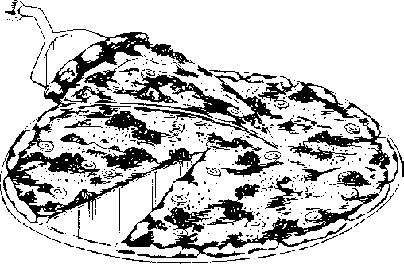English Mufﬁns, preferably whole wheat 1/2 cup fat free refried beans
salsa
chopped onion, optional black olives, optional
½ cup shredded cheese shredded lettuce

Split mufﬁns; toast lightly. Spread beans on toasted mufﬁn halves. Sprinkle with cheese. Broil until cheese is melted about 2 minutes. Garnish with salsa, olives, onion and shredded lettuce.

Yield: 4 servings
Serving Size: One serving is a meat (1/2 oz.) and a grain/bread for a 3- 5 year old at snack.
Credit: Team Nutrition

Orange Tree Salad
1 large bunch fresh broccoli, broken into ﬂorets (about 3 cups) 11 oz. can mandarin orange segments, drained
1/2 c. chopped red onion or 1 onion sliced and separated into rings 1/2 c. low-fat or fat-free French salad dressing

Wash broccoli well and separate into ﬂorets. Add oranges and onions. Toss with dressing and refrigerate at least 30 minutes before serving.

Yield: 12 servings.
Serving Size: One (¼ cup) is serving is one serving of fruit/vegetable for a 3-5 year old at lunch/supper.
Credit: NDSU Extension

B. Smart Graham Delights
1 large graham cracker (2 squares)
peanut butter or fruit ﬂavored cream cheese assorted cut fruit

Spread cracker with either peanut butter or cream cheese. Let the children top their graham cracker with fruit pieces of their choice. Enjoy.

Yield: 1 serving
Serving Size: One cracker is a grain/bread serving for 3 - 5 year old
Note: Not enough fruit to meet fruit portion at snack.

Superman Sweet Potatoes
Recipes
3 medium sweet potatoes (about 1 pound) or 1 (18 oz.) can of sweet potatoes, drained
3 Tbsp. brown sugar 1/8 tsp. ground ginger
8 oz. can peach slices, drained 1 Tbsp. butter or margarine

Cook fresh sweet potatoes, covered, in enough boiling water to cover for 25 to 35 minutes or until tender. Drain and cool slightly. Peel and cut into 1/2-inch thick
slices. Mix brown sugar and ginger. If using canned sweet potatoes, cut them into slices. In a 1-quart casserole, layer half of the potatoes, half the peach slices,
half of the brown sugar mixture and half of the butter. Repeat layers. Bake in 375 degree oven for 30 to 35 minutes until potatoes are glazed. Spoon liquid over potatoes twice during baking.

Yield: 10 servings
Serving Size: 1/4 cup is one serving of fruit/vegetable for a 3-5 year old at lunch supper.
Credit: NDSU Extension

Fruit and Yogurt Cone
assorted chopped and drained fruits fruit ﬂavored yogurt
ice cream cones

Prepare and cut up fruit into bite sized chunks. If using canned fruits, drain thoroughly. Mix together the fruit chunks in a bowl. Place fruit ﬂavored yogurt in a squeeze bottle. Give each child an ice cream cone and let them layer fruit and
yogurt squirted from the bottle into the ice cream cone until full to the top. Eat im- mediately.

Yield: One serving
Serving Size: One fruit cone is a fruit serving (1/2 cup) for a 3-5 year old at snack.
Credit: Providers Choice Staff

